LETS UPGARDE

ASSINGMENT SOLUTION DAY 4

***Name🡪Mohammad Ali Siddiqui***

***Course name🡪 Cyber Security***

***Day🡪4***

***Question 1:***  Find out the mail severs of the following domains

1. Ibm.com

*First open your kali in VM Ware Workstation and in the terminal enter the following commands (in root privilages)*

* nslookup
* >Ibm.com
* >set type=mx
* >Ibm.com
* >[www.Ibm.com](http://www.Ibm.com)

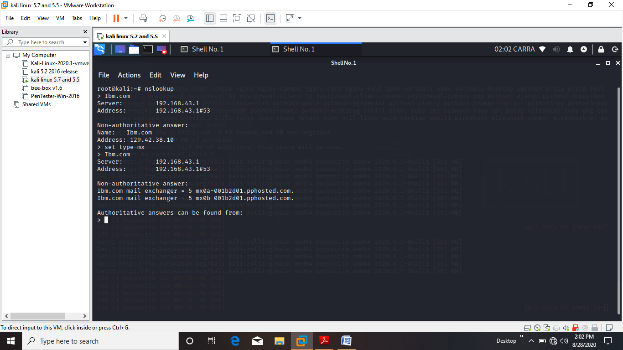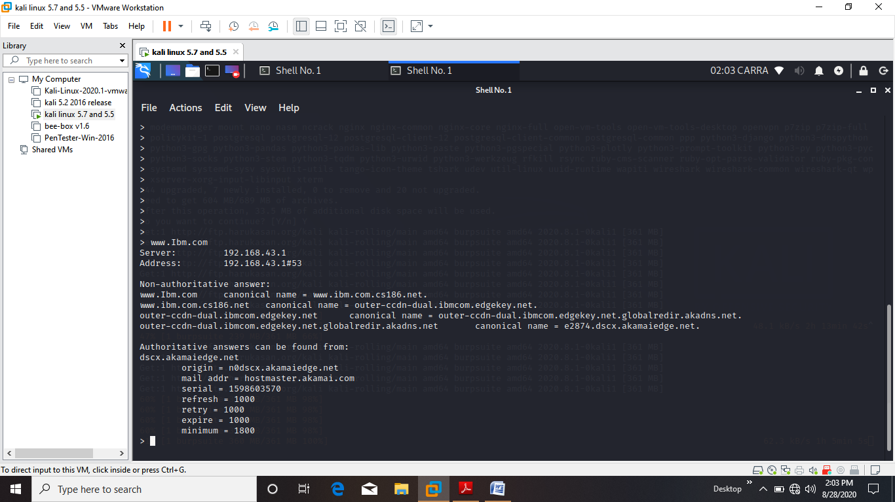

(photos )

under the heading of Authorative Answer I found email server as :

mail addr = hostmaster.akamai.com

1. Ibm.com

*Type in the terminal*

* *exit*

*To exit nslookup*

* *In the terminal with root privilages type the following :*
* nslookup
* >Wipro.com
* >set type=mx
* >Wipro.com
* >[www.Wipro.com](http://www.Wipro.com)

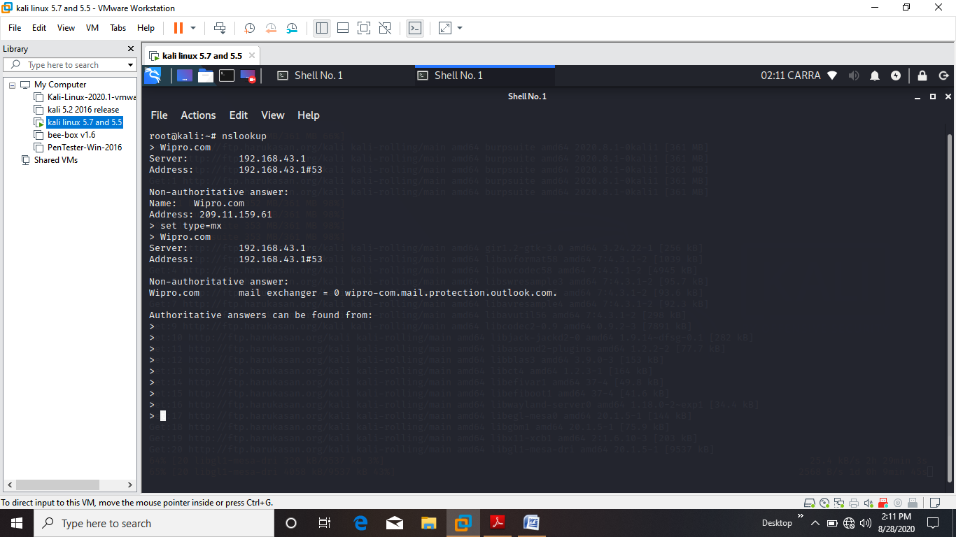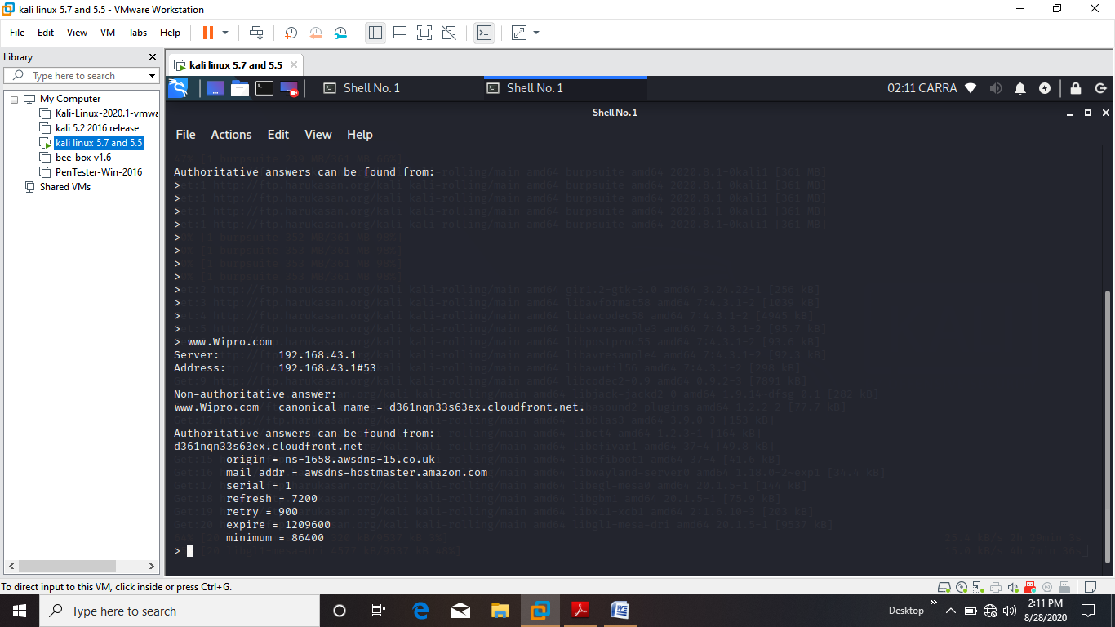

under the heading of Authorative Answer I found email server as :

*mail addr = awsdns-hostmaster.amazon.com*

***Question 2:***  ***Scan and find out port numbers open 203.163.246.23***

***Answer🡪***

***In kali*** *open terminal and type:*

* nmap –Pn –sS ***203.163.246.23***

***this will tell me how many ports are there In total***

***-Pn is to bypass firewall***

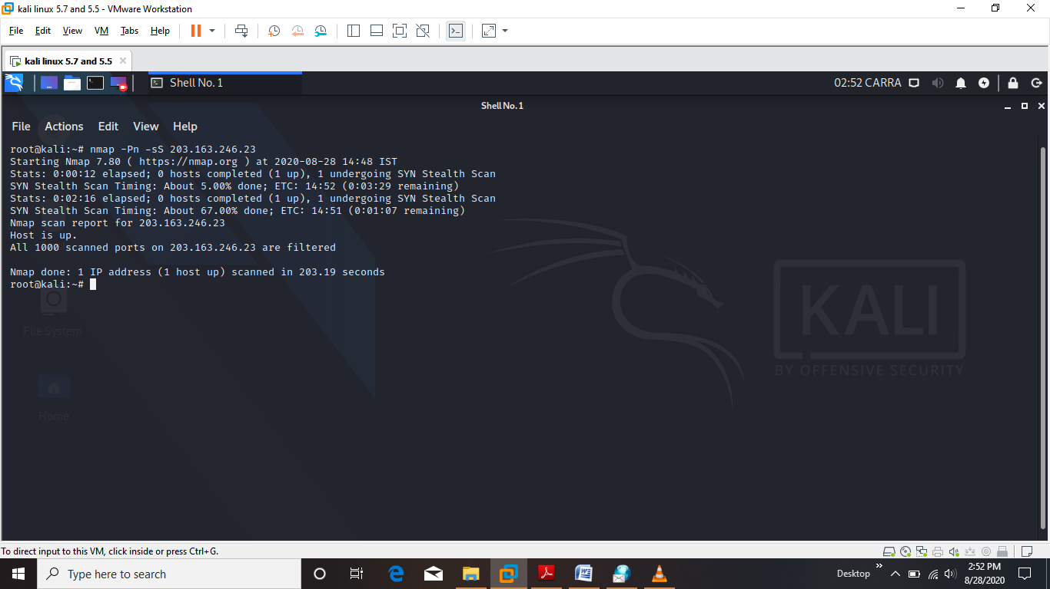

*This told me that there are* **1000 filtered ports**

*Now I can scan this ip with port number*

* *nmap -Pn -p1-1000 -A -v 203.163.246.23*

*-Pn 🡪 to bypass firewall*

*-A 🡪 Aggressive Scan*

*-v 🡪verbose*

*Information is as follows*

